Weixin Liu

[041008492 (Liu00529@algonquinlive.com)](mailto:04100842(Liu00529@algonquinlive.com)/)

**Design-Program**

Project need:

1. Choose dataset from scikit-learn
2. Show data description.
3. Show data shape and feature names
4. Explore data with Pandas (2 tables)
5. Visualizing the features (Many graphs)
6. Splitting data for training and testing then show shapes
7. Training the model
8. Testing the model
9. Visualizing the expected vs predicted prices
10. Metrics and choose best model.

Steps:

1. Get the input from user:
2. Purpose (from sklearn. datasets import fetch_california_housing
3. Allow user to typing the datasets in GUI. Use Entry and Label to create an entry box for user and hints for the input.
4. 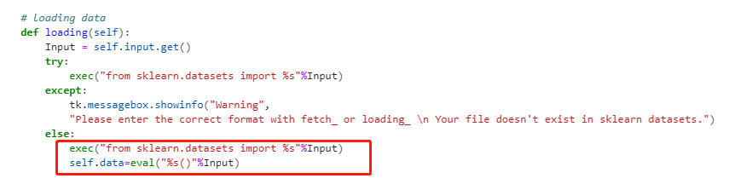Loading data from Sk-learn. Using (Input.get (), exec (), eval ()) to reach the code. However strongly require the user’s input format be correct.
5. Using eval("%s()"%Input) to set the data for following coding.
6. Using if statement to waring the user enter the correct format.
7. Create the buttons on GUI interface (following the order on 15.5 case study)
8. Define the command for all buttons. Basically, same with the code on Case study.
9. Create a list box for display the information on GUI.
10. Using the insert () function to display the information on list box for all “text” information.
11. For graph results:
12. Using matplotlib and seaborn to generate the visual with splitting dataset.
13. Create new windows for the showing graph buttons.
14. For single graph output just using FigureCanvasTkAgg () to drop the graph into the new windows
15. For multiple graphs:

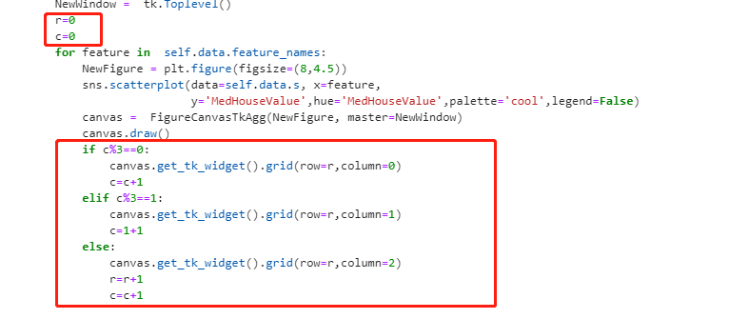

Using the loop and if statements to set the order of the graph position in new window.

1. Creating the quit button for user exit.